Kali test

sendemail -xu 8837f7001@smtp-brevo.com -xp rSKfhnC95IqwYP3V -s smtp-relay.brevo.com:587 -f "nclaude961@gmail.com" -t "niyigabaniyigaba34@gmail.com" -u "promotion" -m "muraho neza"

Mar 28 13:25:28 kali sendemail[150870]: Email was sent successfully!

Or

https://aka.ms/powershell

Type 'help' to get help.

┌──(kali㉿kali)-[/home/kali]

└─PS> sendemail -xu 8837f7001@smtp-brevo.com -xp rSKfhnC95IqwYP3V -s smtp-relay.brevo.com:587 -f "nclaude961@gmail.com" -t "nigabacl@gmail.com" -u "otion" -m "ikazewatsinze"

Mar 28 17:08:29 kali sendemail[265736]: Email was sent successfully!

┌──(kali㉿kali)-[/home/kali]

└─PS>

Q2

Q3

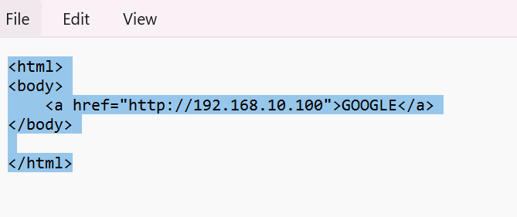

Start in kali

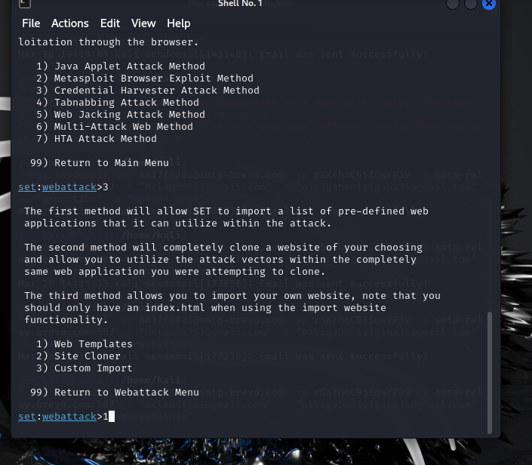

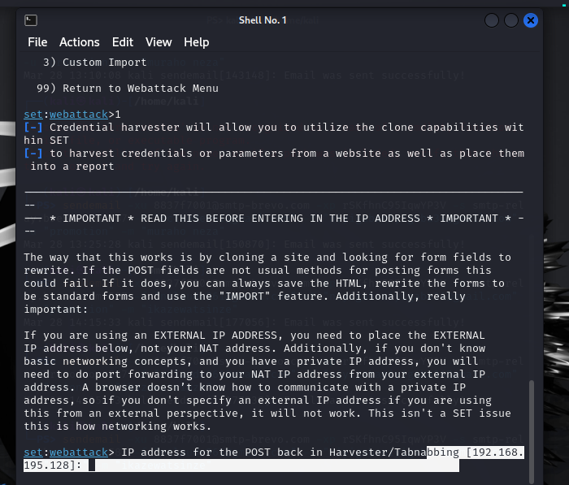

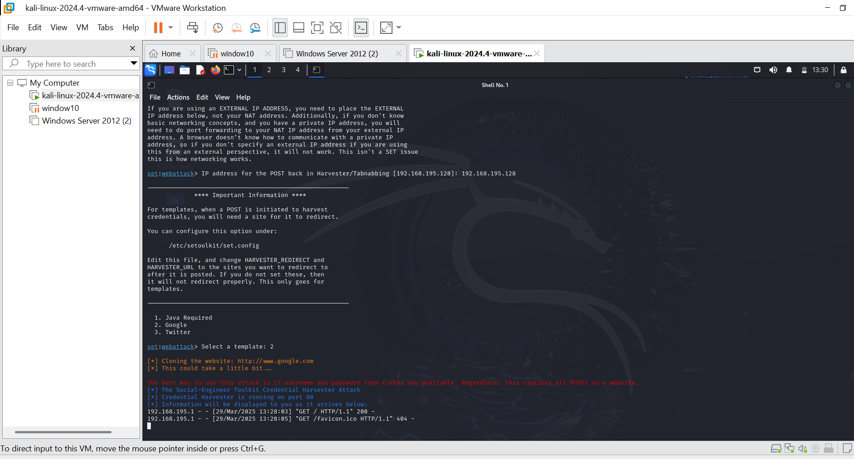

Q3. 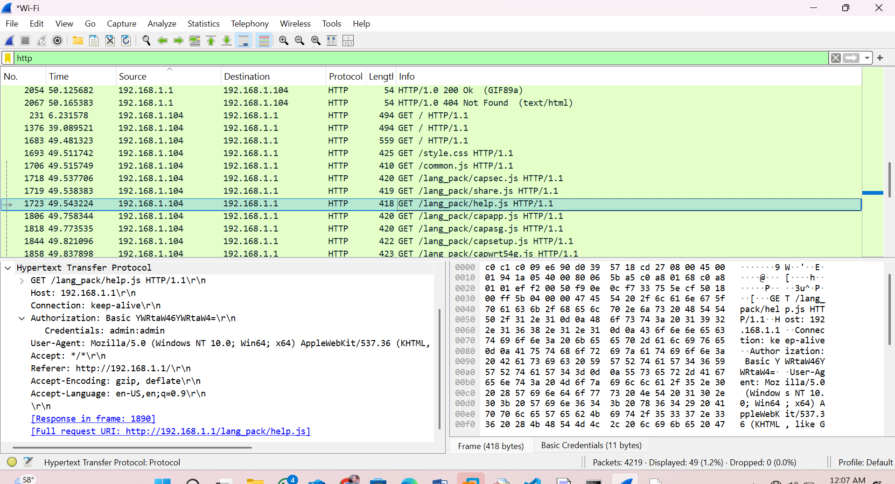

Q7. Unauthorized ip address

1. Snort –v
2. Snort –W
3. Snort -i 4 -c c:\snort\etc\snort.conf –T
4. Snort -i 4 -c c:\snort\etc\snort.conf -A console